PAGE 1 of 3
ITEM  Effective from 21.1.08 | MATCH  REFILL  TO  DISPENSER | PRODUCTS & DISPENSERS PRICE LIST - PRICES PLUS GST -Free delivery metro areas for orders of $90.00 and over - $6.50 delivery fee apply for lesser amount  ALL PAPER ARE QUALITY AUSTRALIAN MADE |  | PK QTY | PRICES  PLUS  GST
CODE |  | TOILET PAPER - HAND TOWEL - TISSUES ETC  ALL PAPER PRODUCTS ARE QUALITY AUSTRALIAN MADE
TP700 | 8 | TOILET ROLLS 2 PLY X 700 SHS SINGLE WRAP (PREMIUM)  “ 700 Sheets Rolls are 3 Times longer that regular Rolls”. |  | 48 | $55.00
TP400 | 8 | TOILET ROLLS 2 PLY X 400 SHS SINGLE WRAP (PREMIUM)  “ 400 Sheets Rolls are 2 times longer than regular rolls” |  | 48 | $45.00
JUMBO2 | 9 | JUMBO TOILET ROLLS 2 PLY X 300 METRES  “Jumbo Rolls are 15 Times longer than regular rolls” |  | 8 | $49.00
HTROLL | 3 & 4 | HAND TOWEL ROLLS 80 METRES PREMIUM |  | 16 | $45.00
HTINTER | 2 | HAND TOWEL INTERFOLD 24X24CM X 150 SHS 2400 SHEETSS PER CARTON |  | 16 | $45.00
HT0-8880 |  | HAND TOWEL SUPER SLIM INTERLEAVED 20X28.5 x 120s |  | 18 | $60.00
HTCF | 5 | HAND TOWEL CENTRE FEED 300 METRES PREMIUM |  | 4 | $42.00
FT |  | FACIAL TISSUES 2 PLY X 100 SHEETS PREMIUM |  | 48 | $42.00
 |  | PAPER & FOAM CUPS/ NAPKINS ETC
FC240 |  | FOAM CUPS 240ML |  | 1000 | $35.00
NK2 |  | NAPKINS 2 PLY |  | 2000 | $42.00
 |  | LIQUID SOAP/HAND CLEANERS/SHAMPOO/CAR WASH
SOAP25 | 1 | LIQUID HAND SOAP/SHAMPOO PREMIUM QUALITY 25 LITRES |  | EA | $70.00
SOAP5 | 1 | LIQUID HAND SOAP/SHAMPOO PREMIUM QUALITY 5 LITRES |  | EA | $16.00
SOAPFOAM1L | 11 | HYGENIFOAM FOAM SOAP REFILL 1 LITRE |  | EA | $15.00
SOAP5FG | 1 | LIQUID SOAP FOOD GRADE |  | EA | $25.00
SOAP25FG | 1 | LIQUID SOAP FOOD GRADE VISCOL 25 LTS |  | EA | $89.00
HCOP5 |  | HAND CLEANER ORANGE POWER W/BEADS & PUMP 5 LTS |  | EA | $39.00
HCSG4 |  | HAND CLEANER SUPA GRIT 4 KG |  | EA | $25.00
HCSG21 |  | HAND CLEANER SUPA GRIT 21 KG |  | EA | $70.00
CODE |  | CHEMICALS, DETERGENTS, LAUNDRY, KITCHEN ETC
DET25 |  | WASHROOM DISINFECTANT/CLEANER 25 LITRES Lemon or Pine | EA |  | $70.00
DET5 |  | WASHROOM DISINFECTANT/CLEANER 25 LITRES Lemon or Pine | EA |  | $16.00
TBC25 |  | TOILET BOWL CLEANER 25 LITRES | EA |  | $70.00
TBC5 |  | TOILET BOWL CLEANER 5 LITRES | EA |  | $16.00
FC25 |  | FLOOR CLEANER CONCENTRATE 25 LITRES | EA |  | $70.00
FC5 |  | FLOOR CLEANER CONCENTRATE 5 LITRES | EA |  | $16.00
SW25 |  | SPRAY AND WIPE ALL PURPOSE CLEANER 25 LITRES | EA |  | $70.00
SW5 |  | SPRAY AND WIPE ALL PURPOSE CLEANER 5 LITRES | EA |  | $16.00
WC25 |  | WINDOW GLASS CLEANER 25 LITRES | EA |  | $70.00
WC5 |  | WINDOW GLASS CLEANER 5 LITRES | EA |  | $16.00
DWL25 |  | DISH WASHING LIQUID SINK 25 LITRES | EA |  | $70.00
DWL5 |  | DISH WASHING LIQUID SINK 5 LITRES | EA |  | $16.00
RA25 |  | RINSE AID 25 LITRES | EA |  | $70.00
RA5 |  | RINSE AID 5 LITRES | EA |  | $16.00
FS25 |  | FABRIC SOFTENER 25 LITRES | EA |  | $70.00
FS5 |  | FABRIC SOFTENER 5 LITRES | EA |  | $16.00
LL25 |  | LAUNDRY LIQUID 25 LITRES | EA |  | $70.00
LL5 |  | LAUNDRY LIQUID 5 LITRES | EA |  | $16.00
NS25 |  | NAPPY SOAKER 25 LITRES | EA |  | $70.00
CODE |  | TOILET & URINAL SANITIZER / CLEANER / DEODORANT
UB5 |  | URINAL DEODORANT BLOCK LEMON 4KG | EA |  | $42.00
BT |  | BIOTABS URINAL MAINTAINER PLASTIC CAGE | EA |  | $6.00
SLB |  | SWEET LOO TOILET SANITIZER/CLEANER IN CISTERN JAR | 12 |  | $72.00
SLC |  | SWEET LOO URINAL SANITIZER/CLEANER IN CISTERN JAR | 12 |  | $72.00
CODE |  | GARBAGE BIN LINERS, CHUCK WIPERS
GB18/27 |  | TIDY & KITCHEN BIN LINERS WHITE 18 0R 27 LITRES | 1000 |  | $35.00
GB54/72/120/240 |  | BIN LINERS BLACK 54 & 72 lts qty 250 per CTN – 120 & 240 lts qty 100 per CTN  ( Please specify size when ordering) |  |  | $35.00
CHUCK85M |  | CHUCK CTN 6 ROLLS X 85 SHEET | 6 |  | $35.00

PAGE 2 of 3
ITEM |  | MATCH  REFILL  TO  DISPENSER |  | PRODUCTS & DISPENSERS PRICE LIST - PRICES PLUS GST  -Free delivery metro areas for orders of $90.00 and over - $6.50 delivery fee apply for lesser amount |  | PK QTY |  | PRICES  PLUS  GST
CODE |  |  |  | METERED AIR FRESHENER & INSECTICIDE FIT MOST AUTOMATIC AEROSOL DISPENSERS
NUSCENT |  | 10 |  | NU-SCENT 3100 METERED SPRAYS (AVAIL IN 8 FRAGRANCES) |  | 12 |  | $72.00
PY-CARE |  | 10 |  | PY-CARE METERED PYRETHRUM INSECTICIDE 150 G |  | 12 |  | $120.00
CODE |  |  |  | DISPENSERS HAND DRYERS ETC
DISPS9 |  | 1 |  | SOAP DISPENSER 900ML WITH LOCK |  | EA |  | $40.00
DISPSF |  | 11 |  | SOAP DISPENSER FOAM 1000 ML WITH LOCK |  | EA |  | $25.00
DISPSSH/V |  | 1 |  | SOAP DISPENSER STAINLESS 500ml VERTICAL & HORIZONTAL |  | EA |  | $80.00
DISPROLL |  | 3 |  | ROLL TOWEL DISPENSER METAL |  | EA |  | $60.00
DISPROLLP |  | 4 |  | ROLL TOWEL DISPENSER PLASTIC |  | EA |  | $60.00
DISPINT |  | 2 |  | INTERFOLD DISPENSER PLASTIC |  | EA |  | $40.00
HDARDM |  |  |  | HAND DRYER ARDRICH AUTO 2.4KW METAL FRONT |  | EA |  | $295.00
HDARDP |  |  |  | HAND DRYER ARDRICH AUTO 2.4 KW ABS PLASTIC FRONT |  | EA |  | $265.00
HDARDSS |  |  |  | HAND DRYER ARDRICH AUTO 2.4KW STAINLESS STEEL FRONT |  | EA |  | $425.00
HD APPLA |  |  |  | HANDDRYER APPLAUSE AUTO 1.6KW |  | EA |  | $265.00
DISPTR3 |  | 8 |  | TRIPLE TOILET ROLL DISPENSER PLASTIC W/LOCK |  | EA |  | $40.00
JUMBOR |  | 9 |  | JUMBO RESERVE DISPENSER (Single Dispenser Avail $40.00) |  | EA |  | $40.00
DISPAER |  | 10 |  | AEROSOL DISPENSER PROGRAMABLE WITH LCD DISPLAY |  | EA |  | $60.00
ECODISP |  | 7 |  | ECOWIPES DISPENSER PLASTIC WITH LOCK |  | EA |  | $40.00
BCTPO |  |  |  | BABY CHANGE TABLE OVAL |  | EA |  | $550.00
BCTPV |  |  |  | BABY CHANGE TABLE VERTICAL |  | EA |  | $550.00
BCTPH |  |  |  | BABY CHANGE TABLE HORIZONTAL |  | EA |  | $550.00
BCTM |  |  |  | BABY CHANGE TABLE PIPI METAL |  | EA |  | $410.00
CODE |  |  | MISCELLANEOUS ITEMS
TAP |  |  | 25 LITRE DRUM TAP |  | EA |  | $2.50
TOOL25 |  |  | 25 LITRE DRUM OPENING TOOL |  | EA |  | $12.00
PUMP5 |  |  | 5 LITRE DRUM PUMP |  | EA |  | $4.50
CODE |  |  |  | INSTALLATIONS ( MINIMUM COST $60.00 plus GST)  Discount for multiple installations
INSTBCT |  |  |  | BABY CHANGE TABLE |  | EA |  | $140.00
INSTDISP |  |  |  | WASHROOM DISPENSERS- SOAP / HAND TOWEL / TOILET PAPER ETC |  | EA |  | $20.00
INSTHD |  |  |  | HAND DRYER (NOT INCLUDING POWER POINT) |  | EA |  | $60.00

PAGE 3 of 3

SOAP DISPENSER  CODE: DISPS9  $40.00  Match Consumable 1  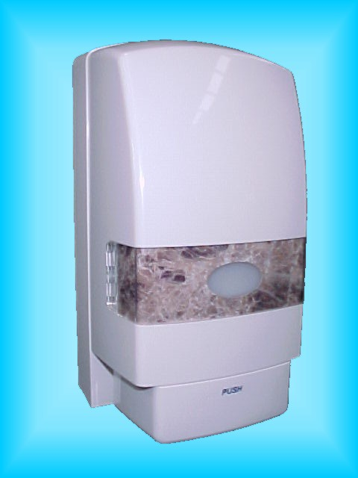 | SOAP DISPENSER FOAM  CODE: DISPSFO  $25.00  Match Consumable 11  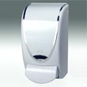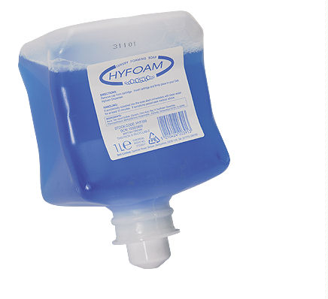 |  | SOAP DISPENSER STAINLESS 600 Ml  CODE: DISPSSV  CODE:DISPSSH  $80.00  Match Consumable 1  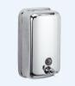 | 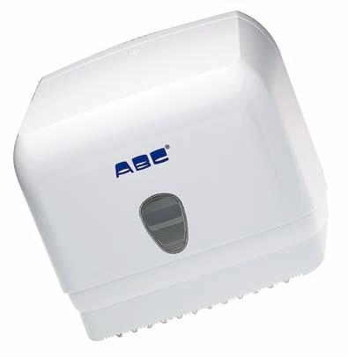 ROLL TOWEL DISPENSER  CODE: DISPROLLM  $60.00  Match Consumable 3  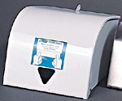
ROLL TOWEL DISPENSER  PLASTIC  CODE: DISPROLLP  $60.00  Match Consumables 4  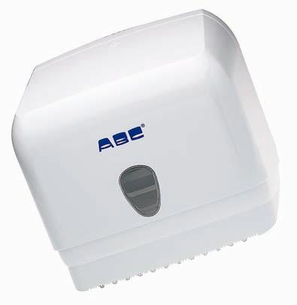 | INTERFOLD DISPENSER  CODE:DISPINT  $40.00  match consumables 2  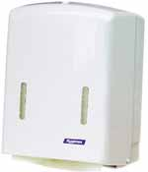 |  | HAND DRYER 2.4KW METAL  CODE: HDARDM  $295.00  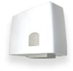 | HAND DRYER 2.4KW PLASTIC  CODE: HDARDP  $265.00  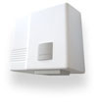
HAND DRYER 2.4KW STAINLESS  CODE: HDARDSS  $425.00  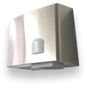 | HAND DRYER 1.6 KW METAL  CODE: HDAPPLA  $265.00  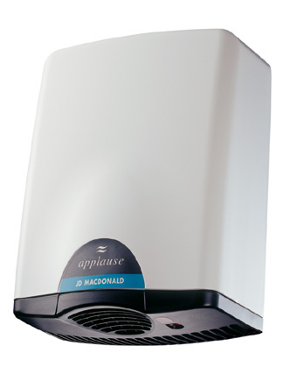 |  | TOILET ROLL DISPENSER  CODE: DISPTR3  $40.00  Match Consumable 8  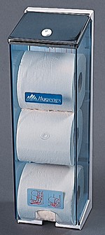 | JUMBO TOILET ROLL DISPENSER WITH RESERVE ROLL  CODE: JUMBOR  $40.00  Match Consumables 9  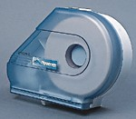
AEROSOL DISPENSER  CODE:DISPAER  $60.00  match consumables 10  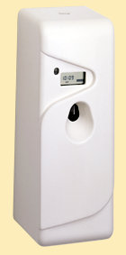 | ECO-WIPE DISPENSER  CODE: ECODISP  $40.00  Match Consumable 7  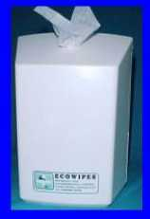 | BABY CHANGE TABLE  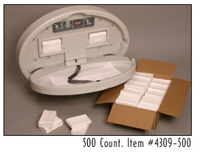  CODE: BCTO BCTV BCTH $550.00  